Group-32

Harsh Patel – 100852669

Raquim Dockery 100660304

Christopher Fowler 100711442

Capstone Project DCOM 4100

IPSLA, QoS, NAT, ACLs

Table of Contents

NAT 2

ACLs 2

IPSLA 4

QoS 5

# NAT

# ACLs

# IPSLA

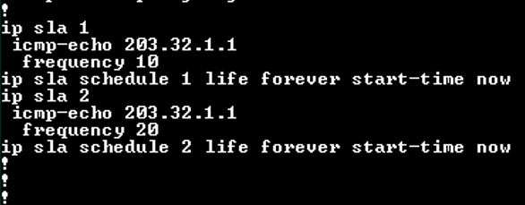

Branch—

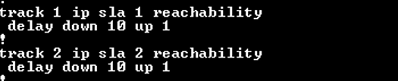



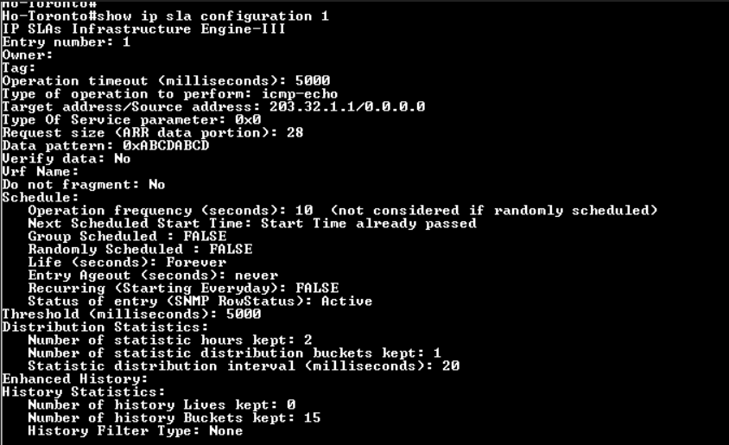

# QoS



